# Rossmoyne Senior High School

### Semester One Examination, 2015

### Question/Answer Booklet

**SOLUTIONS**

# MATHEMATICS 3A

## Section One:

## Calculator-free

|  |  |  |  |  |  |  |  |  |
| --- | --- | --- | --- | --- | --- | --- | --- | --- |
| Student Number: In figures |  |  |  |  |  |  |  |  |

In words

Your name

## Time allowed for this section

Reading time before commencing work: five minutes

Working time for this section: fifty minutes

## Materials required/recommended for this section

##### *To be provided by the supervisor*

This Question/Answer Booklet

Formula Sheet

##### *To be provided by the candidate*

Standard items: pens (blue/black preferred), pencils (including coloured), sharpener,

correction fluid/tape, eraser, ruler, highlighters

Special items: nil

## Important note to candidates

No other items may be taken into the examination room. It is **your** responsibility to ensure that you do not have any unauthorised notes or other items of a non-personal nature in the examination room. If you have any unauthorised material with you, hand it to the supervisor **before** reading any further.

## Structure of this paper

|  |  |  |  |  |  |
| --- | --- | --- | --- | --- | --- |
| Section | Number of questions available | Number of questions to be answered | Working time (minutes) | Marks available | Percentage of exam |
| Section One:  Calculator-free | 7 | 7 | 50 | 50 | 33⅓ |
| Section Two:  Calculator-assumed | 13 | 13 | 100 | 100 | 66⅔ |
|  | | | **Total** | 150 | 100 |

## Instructions to candidates

1. The rules for the conduct of Western Australian external examinations are detailed in the *Year 12 Information Handbook 2015*. Sitting this examination implies that you agree to abide by these rules.
2. Write your answers in this Question/Answer Booklet.
3. You must be careful to confine your response to the specific question asked and to follow any instructions that are specified to a particular question.
4. Spare pages are included at the end of this booklet. They can be used for planning your responses and/or as additional space if required to continue an answer.

* Planning: If you use the spare pages for planning, indicate this clearly at the top of the page.
* Continuing an answer: If you need to use the space to continue an answer, indicate in the original answer space where the answer is continued, i.e. give the page number. Fill in the number of the question that you are continuing to answer at the top of the page.

1. **Show all your working clearly**. Your working should be in sufficient detail to allow your answers to be checked readily and for marks to be awarded for reasoning. Incorrect answers given without supporting reasoning cannot be allocated any marks. For any question or part question worth more than two marks, valid working or justification is required to receive full marks. If you repeat any question, ensure that you cancel the answer you do not wish to have marked.
2. It is recommended that you **do not use pencil**, except in diagrams.
3. The Formula Sheet is **not** to be handed in with your Question/Answer Booklet.

Section One: Calculator-free (50 Marks)

This section has**seven (****7)** questions. Answer **all** questions. Write your answers in the spaces provided.

Working time: 50 minutes.

Question 1 (4 marks)

Shade the region in each Venn diagram below to represent

(a) . (2 marks)

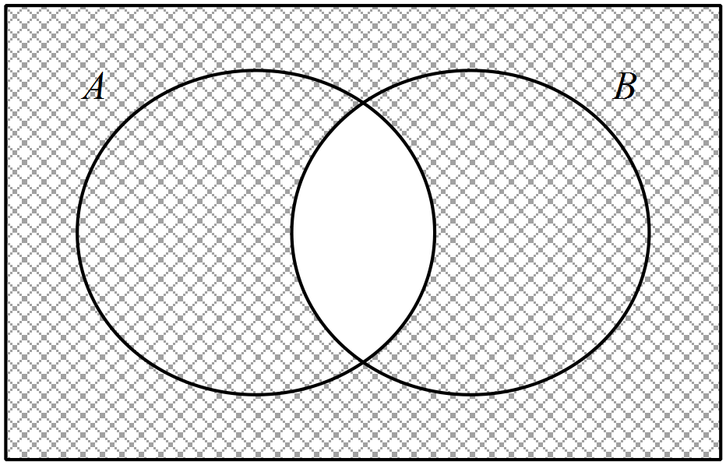

(b) . (2 marks)

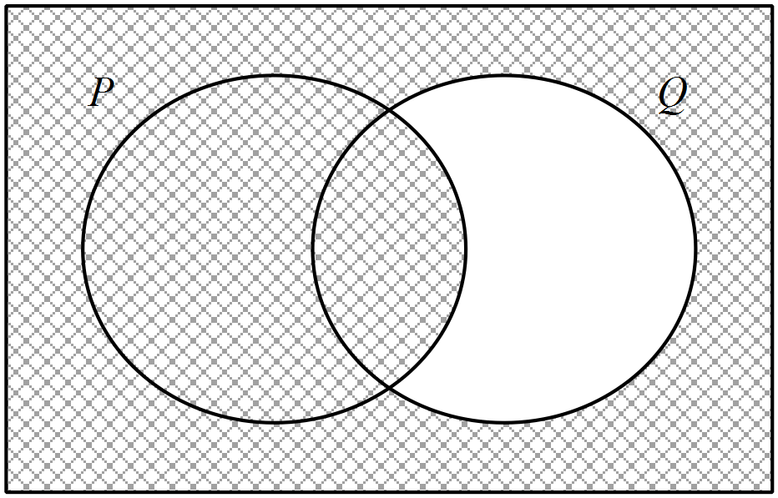

Question 2 (9 marks)

The functions ,  and  are graphed below.

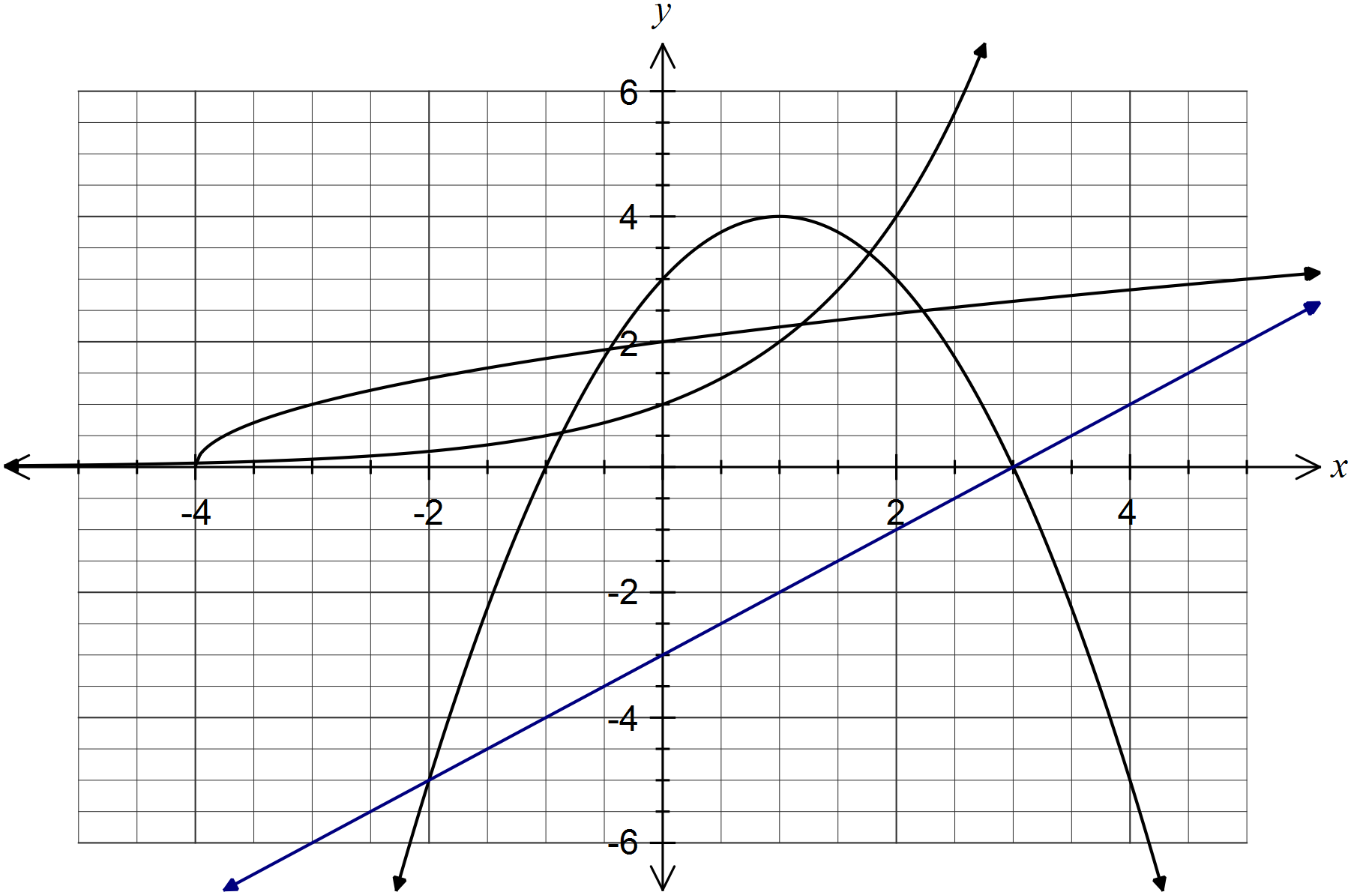

(a) One of the functions has an asymptote. State the equation of this asymptote. (1 mark)

Function  has asymptote with equation .

(b) One of the functions has a line of symmetry. State the equation of this line of symmetry.

(1 mark)

Function  has line of symmetry .

(c) Use the graph to solve the following equations.

(i) , for . (2 marks)



(ii) , for . (2 marks)



(iii) , for , by drawing a suitable straight line on the graph. (3 marks)



Question 3 (5 marks)

44% of students enrolled in a math course at a university were male. 22% of the students enrolled were retaking the course and of these students, half were female.

(a) Determine the percentage of enrolled students in the math course who were males retaking the course or females not retaking the course. (3 marks)

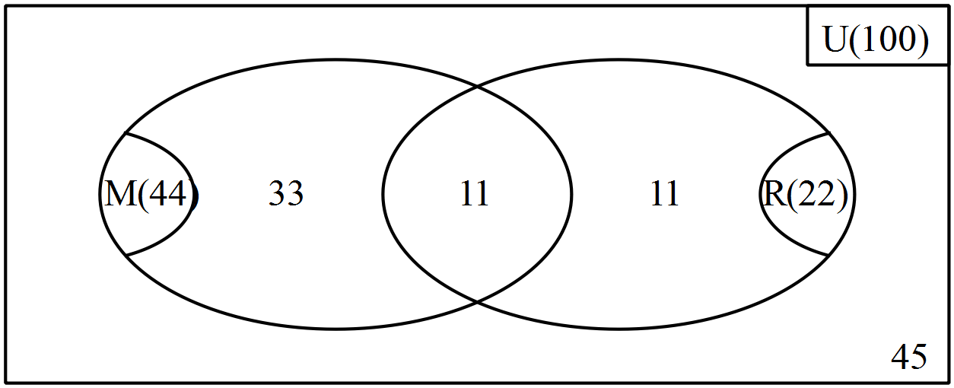

Solution: 11 + 45 = 56%

(b) Determine the probability that a randomly chosen female student enrolled in the course was retaking it. (2 marks)



Question 4 (9 marks)

Solve the following equations for .

(a) . (2 marks)



(b) . (2 marks)



(c) . (2 marks)



(d) . (3 marks)



Question 5 (8 marks)

The duration of telephone calls to a call centre are normally distributed with a mean of 225 seconds and a standard deviation of 35 seconds. All calls are recorded for training purposes.

(a) Determine the probability that a randomly chosen call from the records has a duration of

(i) between 120 and 330 seconds. (1 mark)



(ii) more than 260 seconds. (2 marks)



(b) If 50 calls were randomly selected from the records, how many would be expected to have a duration of between 190 and 260 seconds? (2 marks)



(c) At a similar call centre, the duration of calls were also normally distributed. Records showed that 68% of calls were between 165 and 195 seconds and 95% of calls were between 150 and 210 seconds. Use this information to estimate the mean and standard deviation of the duration of calls at this centre. (3 marks)



Question 6 (9 marks)

(a) Evaluate . (2 marks)



(b) Simplify . (2 marks)



(c) Solve the following equations for .

(i) . (2 marks)



(ii) . (3 marks)



Question 7 (6 marks)

(a) In triangle ,  cm,  cm and  cm. Determine the length of side .

(2 marks)



(b) In triangle , the length of the sides and  are 8 cm and 16 cm respectively. If the value of sin, determine the value of sin . (2 marks)



(c) In triangle  , sin and the lengths of ,  and  are 14 cm, 12 cm and 7 cm respectively. Determine the area of the triangle. (2 marks)



Additional working space

Question number: _________

This examination paper may be freely copied, or communicated on an intranet, for non-commercial purposes within educational institutes that have purchased the paper from WA Examination Papers provided that WA Examination Papers is acknowledged as the copyright owner. Teachers within Rossmoyne Senior High School may change the paper provided that WA Examination Paper's moral rights are not infringed.

Copying or communication for any other purposes can only be done within the terms of the Copyright Act or with prior written permission of WA Examination papers.

*Published by WA Examination Papers*

*PO Box 445 Claremont WA 6910*